2

**St Mary Redcliffe Church of England Primary School**

Maths Policy



**Introduction**

At St Mary Redcliffe Church of England Primary School we believe that mathematics equips pupils with a uniquely powerful set of tools, through developing an ability to calculate, reason and solve problems. It enables children to understand and appreciate relationships and patterns in both number and space in their everyday lives. Through their growing knowledge and understanding, they also learn to appreciate the contribution made by many people to the development and application of mathematics.

It is our aim to develop:

• A growth mindset about ability to learn mathematics

• A positive attitude towards mathematics and an awareness of how fascinating elements of mathematics can be

• Competence and confidence with numbers and the number system and other mathematical knowledge, concepts and skills

• Problem solvers, who can reason, think logically, work systematically and apply their knowledge of mathematics

• An ability to communicate using mathematical language

• An ability to work both independently and with others.

**Our Aim for 2023-24**

At St Mary Redcliffe CE Primary School, our aim this year will be to adopt follow the Mathematics Mastery Approach to teaching Mathematics using the White Rose Maths Hub schemes of work and planning materials.

We aim to deliver high quality maths lessons using the following key principles:

This approach has mathematical problem solving at its heart and has three key principles, we teach children to:

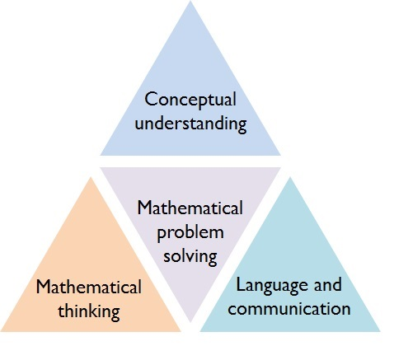

1. Use spoken and written [language](http://toolkit.mathematicsmastery.org/training/view/27) with confidence and clarity to explain and justify mathematical reasoning.
2. Have a deep conceptual[understanding](http://toolkit.mathematicsmastery.org/training/view/29) of mathematical concepts.
3. Develop [mathematical thinking](http://toolkit.mathematicsmastery.org/training/view/28/principles/mathematical-thinking), including generalising, classifying and comparing, and modifying.

**Teaching and Learning**

Teachers’ planning and organisation

As of September 2017 we began following the White Rose Mathematics Mastery programmes of study, which ensures continuity and progression in the teaching of mathematics. Within a unit of work, the time spent on teaching a specific learning objective or set of learning objectives depends on the needs of the children.

All teachers plan daily mathematics lessons following this structure using an agreed planning format. Weekly planning includes learning objectives, key vocabulary, possible misconceptions and the journey of learning can be seen.

Where possible teachers pre-empt ‘big’ misconceptions that many children will have – eg a rectangle/oblong has four lines of symmetry (diagonals). Teachers also plan which vocabulary they will use and which models, images and concrete resources they will use to aid learning.

We ensure that across each term children are given a range of experiences in mathematics lessons e.g. practical activities and mathematical games, group problem solving activities, individual, group and whole class discussion activities, open and closed tasks. We ensure that children can use a range of methods to calculate and have the ability to check whether their chosen methods are appropriate, reliable and efficient.

A separate ‘Calculation Policy’ has been written by the staff at St Mary Redcliffe CE Primary School and will also be adopted in school to ensure complete continuity and gradual development of number skills.

Differentiation

Our staff has high expectations of all children, irrespective of ability, and encourage them to be successful and achieve their full potential. Our aim is to ensure challenge for all. Children are encouraged to have a growth mindset about their ability to do mathematics. Encouraging children to ‘have a go’ is seen as paramount.

We aim to develop the mantra: The Power of Yet! We want to encourage the children to have multiple attempts at a problem in order to find the solution.

In some lessons children ‘self-differentiate’ and choose the level of challenge right for them. In other lessons, teachers direct children to the correct level of challenge based on their assessment in the initial phases of the lesson.

Differentiation of tasks is done in various ways:

* Open ended questioning and activities which allow more able children to offer more sophisticated mathematical responses
* Stepped Activities which can be accessed at different steps, supporting and challenge all.
* Recording e.g. allowing some children to give verbal responses and photographing their learning
* Resourcing eg. Use of cubes, 100 squares, number lines, mirrors to support some children
* Grouping according to ability so that the groups can be given different tasks when appropriate. Activities are based on the same theme. Part of independent work often involves some focused, targeted group work from the teacher. However groupings are ‘fluid and flexible’ based on the needs of individual pupils.



Assessment

We recognise that AfL lies at the heart of promoting learning and in raising standards of attainment. We further recognise that effective AfL depends crucially on actually using the information gained.

The assessment procedures within our school encompass:

* Making ongoing assessments and responding appropriately to pupils during ‘day-to-day’ teaching.
* Provide the children with ‘growth’ marking which will record progression and pupil/teacher feedback.
* Using knowledge of pupils drawn from ongoing pupil objective tracking records to guide our planning and teaching;
* Adjusting planning and teaching within units in response to pupils’ performance in lessons and through ‘hot’ and ‘cold’ tasks.
* Using NFER assessments in terms 2, 4 and 6 to gather information about how well the children are accessing maths and where the gaps in understanding are.

Vocabulary and precision of language

Developing children’s language and vocabulary is absolutely essential.

* In all lessons attention is given to whether key vocabulary has been learnt.
* Key vocabulary is listed on the maths learning walls in each classroom during lessons and instantly added to as new words arise.
* Paired talk activities are used to encourage children to talk about their mathematics.
* Teachers insist that children mirror the language they hear the adults using.
* Where appropriate, children are encouraged to answer in full sentences.
* Adults mirror back alternative words for the same meaning to enrich children’s range of vocabulary. E.g. Child says ‘3 times 5 is 15’, teacher says, ‘yes, the product of 3 and 5 is 15’ or ‘3 multiplied by 5 equals 15’.
* Children are required to provide justification and reasoning for their answers. For example, ‘I know the shape is a square because….’
* Teachers are required to have sound subject knowledge and understanding of the correct terminology and vocabulary and they refer to the school’s glossary of maths terms if unsure. E.g. there is no such thing as a ‘take away’ sum (because ‘sum’ means ‘add’). We use the terms ‘calculation’ or ‘equation’.

